Notes from the Field: Documentation of The Tboli Festival of Stories (July 20-21, 2024) IAA Project Phase I

Prepared by Maria Cristina Juan and Benjie M. Manuel

Background

In April 2023, a grant from SOAS IKE (Impact and Knowledge Exchange Fund) facilitated a project enabling a British woman to personally return significant Tboli artifacts to Lake Sebu. This return was not just a ceremonial act but a profound gesture that paved the way for a cultural renaissance among the Tboli people. Tboli school teacher Benjie Manuel pledged approximately three quarter of an acre of land for the Gónô Tmutul and its surrounding area as a reciprocal gesture for being selected as the custodian of the repatriated items. Notably, Manuel, a high school public teacher and head of school, spearheaded the development of the first indigenous knowledge-based curriculum officially recognized by the Philippine public education system. Under his leadership, the new Gónô Tmutul (House of Storytelling in Tboli) took on the responsibility of safeguarding the repatriated materials.

Throughout the year, other Tboli elders and leaders joined forces to form a collective, contributing their own family heirlooms to Gono as they continued to expand the collection. This collective effort not only enriched the Gónô Tmutul's repository but also fostered a sense of community ownership and pride.

The return of these artifacts sparked collaborative research into the cosmologies and traditional contexts surrounding Tboli material cultures. This research has been documented within the global inventory of the Mapping project and shared through presentations at conferences and symposia. The co-produced research in Tboli material culture and the process by which this production of knowledge has been reached serve as a blueprint for heritage re-ownership and research led by local source communities. This approach underscores the importance of engaging indigenous communities in the preservation and interpretation of their own cultural heritage.

In July 2024, follow up funding from a SOAS IAA grant (Impact Acceleration Account) allowed for the envisioning of an inaugural Tboli storytelling festival that would be timed with the ground breaking ceremony of the physical Tboli House of Stories (Gónô Tmutul) at Lake Sebu.

Rationale

The festival is meant to gather Tboli epic chanters and elderly storytellers along with the Tboli youth. The format would allow for the remobilization of traditional narrative forms to reconnect material and intangible dimensions of Tboli culture. The proposed project would encapsulate a multi- and transdisciplinary field involving the repatriated materials, oral tradition, discussion, and educational materials production. The festival format also sought to animate the sense of place for the Tboli who in recent years, have been missing open spaces for gatherings. Most of their ancestral lands have been sold off, either through indentured debt or to negotiations with entrepreneurial migrants to the area who convert lakefront lands into resorts for tourists. The grant allowed the Gono collective to develop this open land dedicated to the House for Storytelling and see in real time what the structures and performative programming might look like through this inaugural event.

The festival foregrounds the performative dimensions of storytelling, with the festive atmosphere elevating and enabling knowledge transmittal from dramatic voice and instrumentation. On top of the storytelling, the performative is intimately connected to technologies of making, notably ikat-dyeing, brass casting, beadworking, and other visual/plastic expressions through workshops with artisans. In the reintegration of Tboli traditional culture, the programmatic intent is to reconstitute the seamlessness among the arts and traditional Tboli culture. Within this festival space, we will also be co-producing materials for publication of Tboli educational materials for both High School and Elementary aged children.

Gónô Tmutul's pillar is epic chanting and traditional storytelling, staged with minimal mediation between performer and audience. The music and oral literature focus will focus on the cosmological complexes and mythic significance of the relevant ikat-dyed textiles, cast brass, and ritual-adornments of the Tboli and creating a space to reconnect both the tangible and the intangible in a communal space.

A Chronology of Events

Under the leadership of Benjie Manuel, the Gono collective gathered well regarded Tboli storytellers and cultural leaders like Boi Myrna Pula and Mechie Belleza, chanters and ritualists to put togther a two-day programme of events set up entirely by the members of the Gono collective. The programme was drafted and submitted to the Department of Education Region XII Soccskargen Schools Division of South Cotabato for approval, and considered as an official extra-curricular activity under Tboli Sbu Senior High School Lamdalag, Lake Sebu, South Cotabato. Being a community-led event, the National Commisison for Indigenous Peoples (NCIP) did not need to give express permission to hold the event.
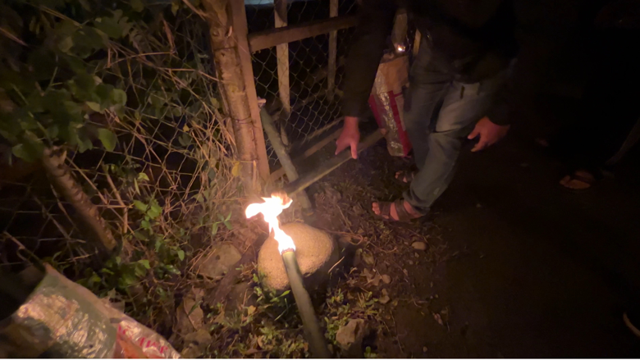
On Day 1, the Festival began at 6:00 AM with a Milo bè Gónô Tmutul, or a dawn parade, where community members took up bamboo torches walking from the center of the Barrio towards Gono Tmutul. From memories of older times, the parade was a way to mark an event and a call to the local community to join.

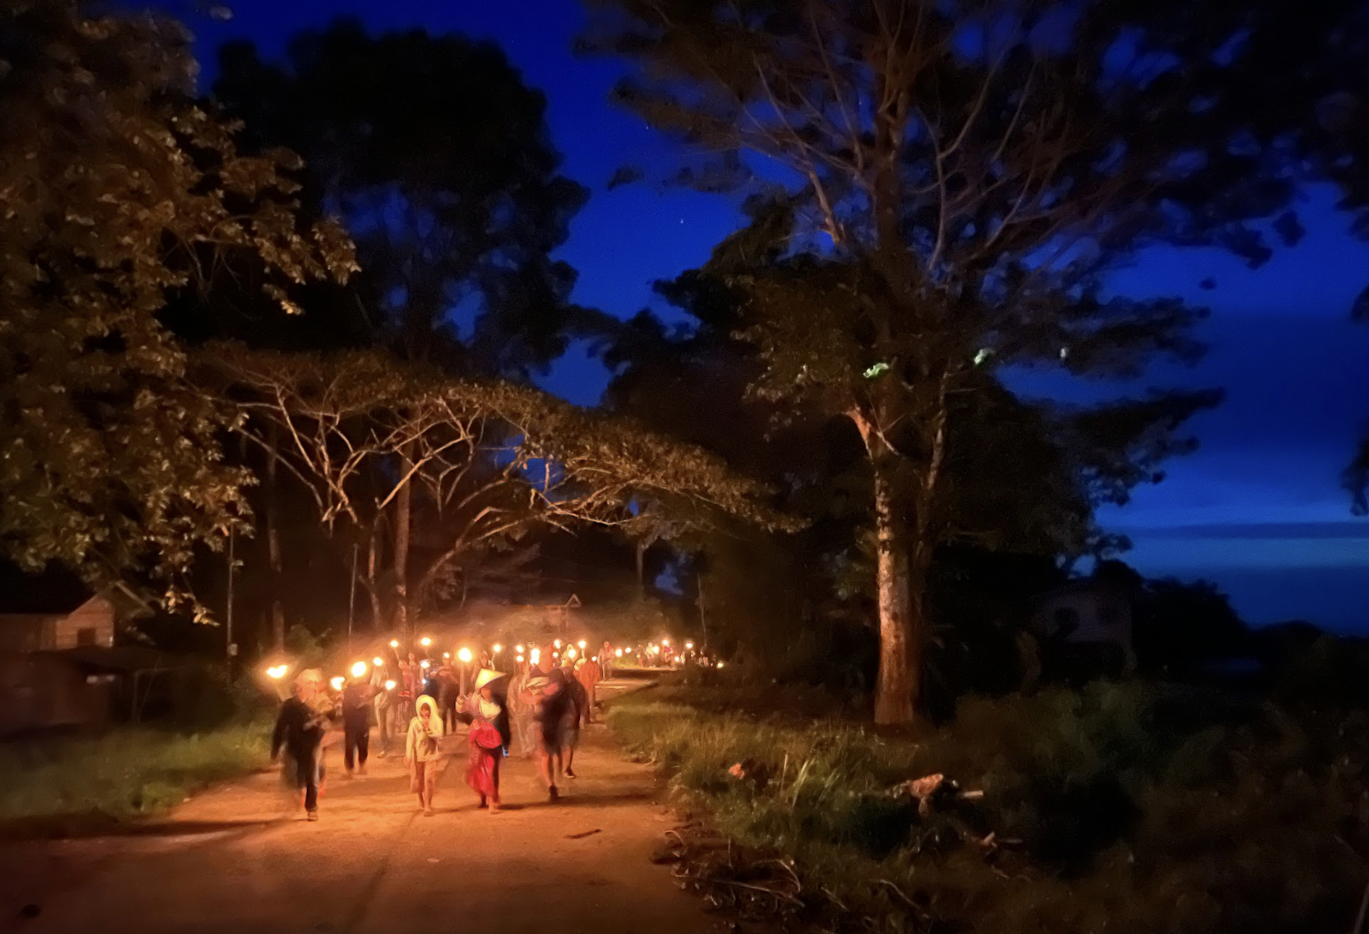
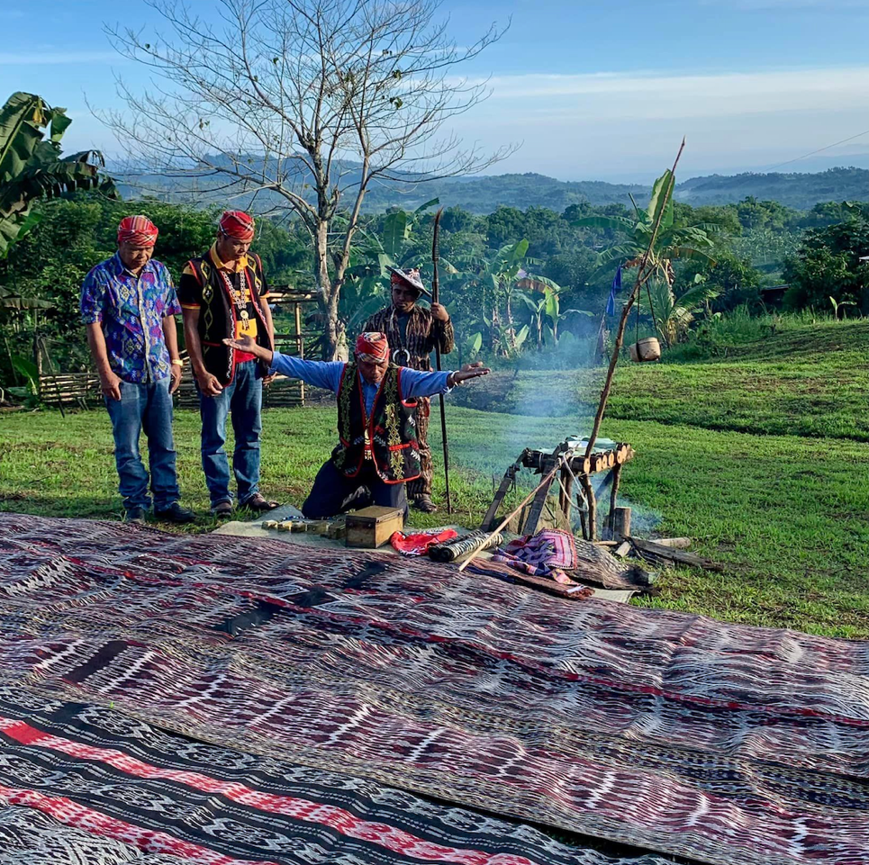

By 7:00 AM, the group reached the Gono site where the Demsù bè Gónò Mahan ( or Tboli ritual rites) were led by Datu Simeon Paran and Témê Anduy Ofong, along with Benjie Manuel and the participants. The rites consisted of bringing out the Tboli artefacts from its storage and laying down the pieces around a Gono Mahan ( ritual structure).

This included Tnalak pieces taken out from storage, held up or laid on the grass, along with armlets, Tboli hair adornments, brass ornaments etc.

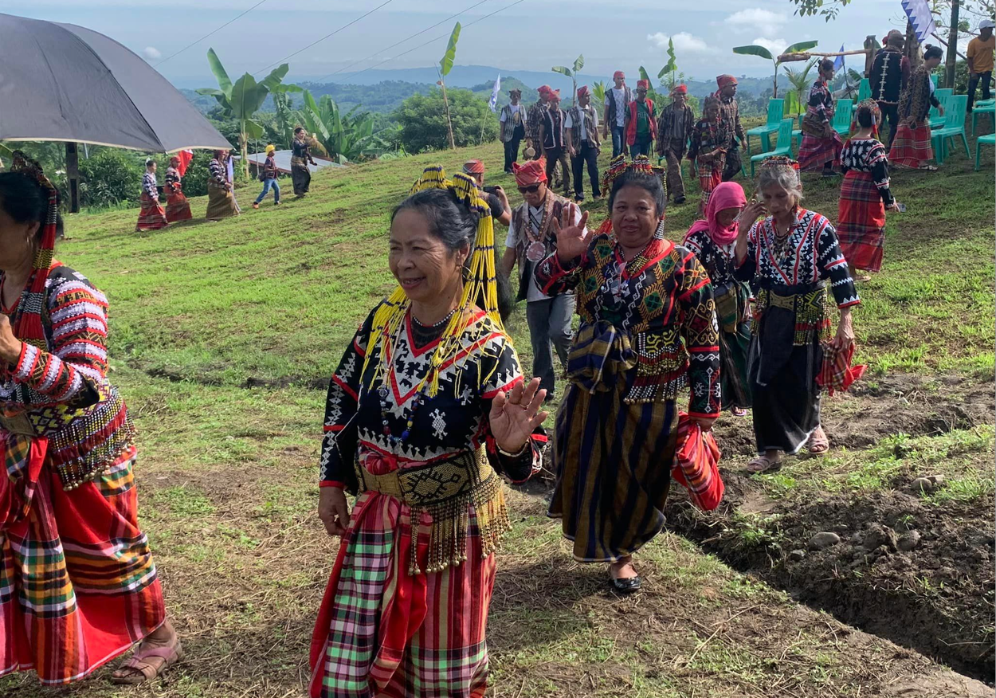

A crowd of over 100 participants came to gather at the Gono space. Tboli Elders from more far-flung areas around Lake Sebu were invited to join in the festivities. There were three freshly built bamboo structures around the open central space to act as stages for the unfolding of the events. There were invitations, banners, portable toilets.

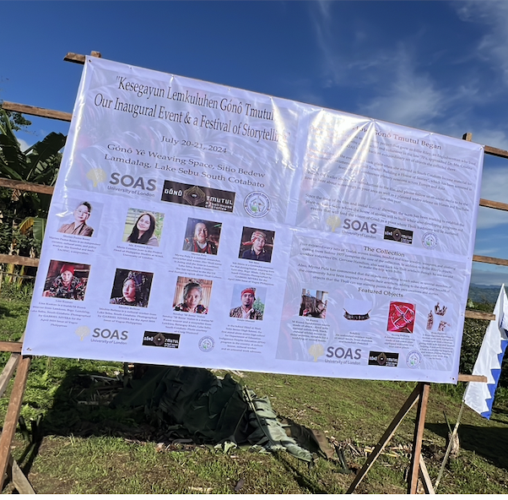

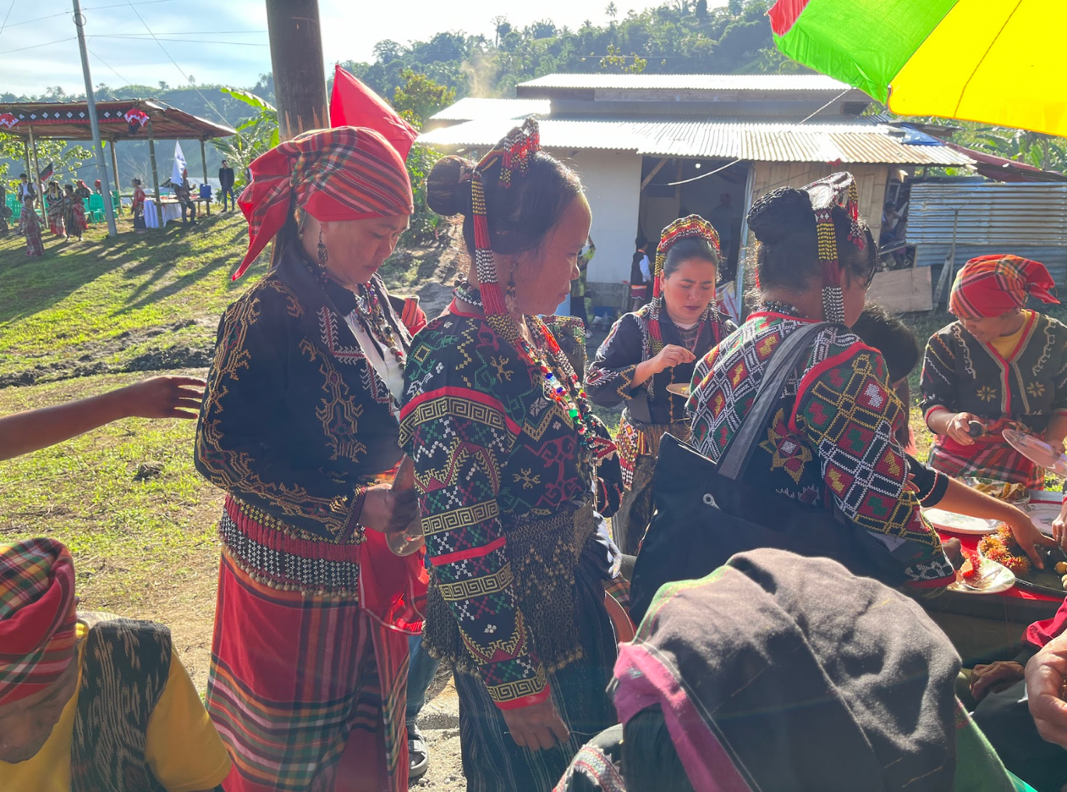
A communal breakfast followed. There was a lot of food prepared by volunteers. A whole pig was butchered and was used to cook several meals throughout the event.

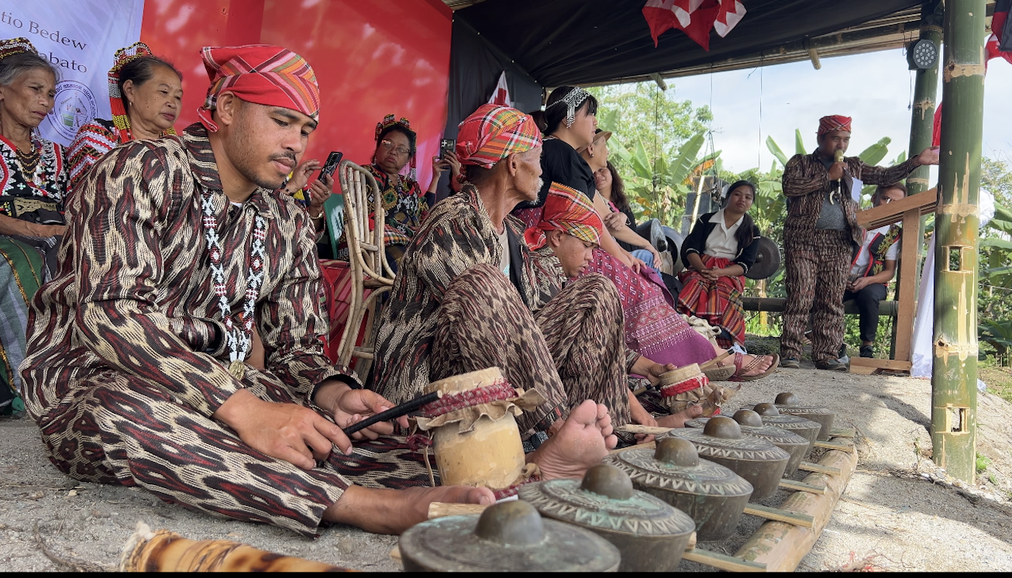

By 8:00 AM, the program started with a Ktaba be Dwata or Prayers by the Elders, a rendition of the Philippine National Anthem with Barangay officials in attendance. This was followed by a a welcome dance and opening Remarks/Welcome Message by Boi Myrna B. Pula and a brief welcome and rationale of the Activity by Maria Cristina Juan.

There were also messages of welcome by Hon. Roger A. Ben, Punong Barangay and Hon. Remie M. Unggol, the Municipal Mayor. The officers and members of the Gono collective were introduced by Mr. James Baay, Chairman. (see Appendix A for their meeting minutes and articles of incorporation)

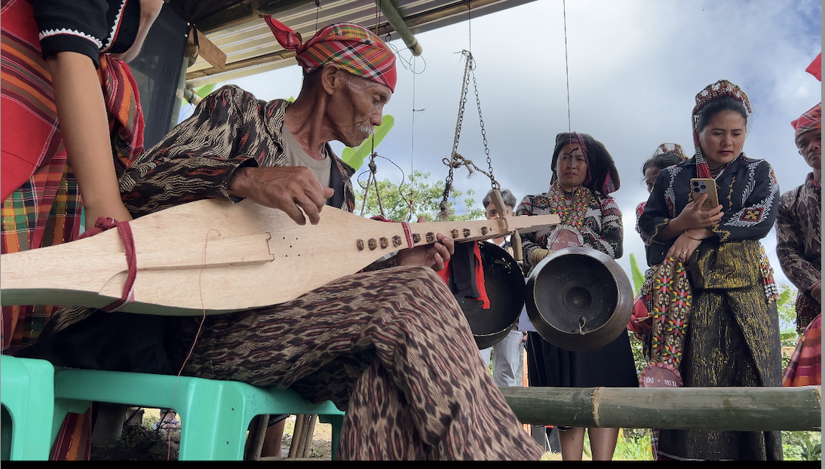

The rest of the morning was a series of Helobung/Kesedutung kem utom where Tboli Sbu High School students danced along with the Elders, along with young and older musicians.

Storytelling sessions followed (Kesetutul/Storytelling/Kesetutul kem tau tino) interspersed with the playing of Tboli musical instruments by both young and older musicians.

There was a recitation of the epic chant called Tud bulul – specifically looking at part so the epic chant for interconnections between myth and material culture.
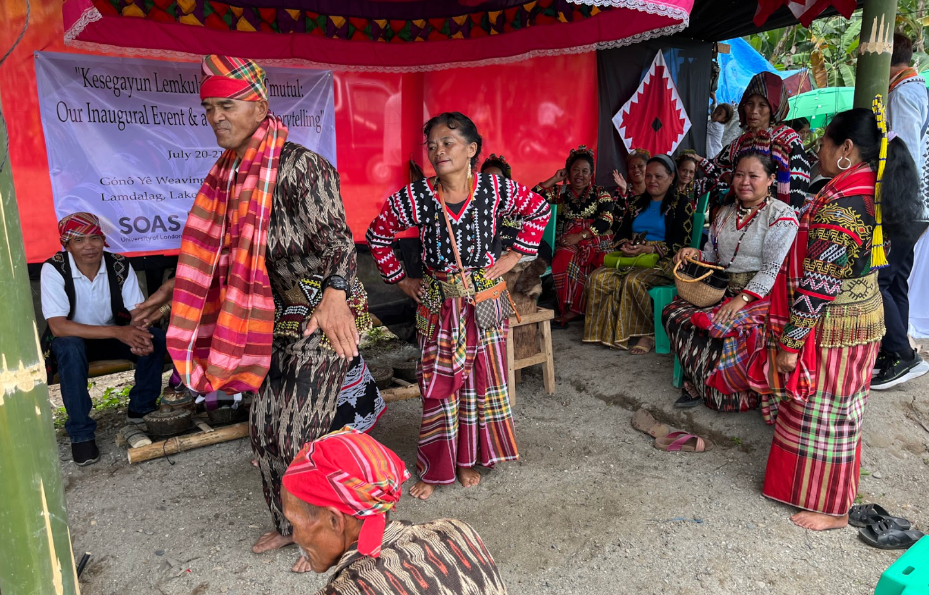
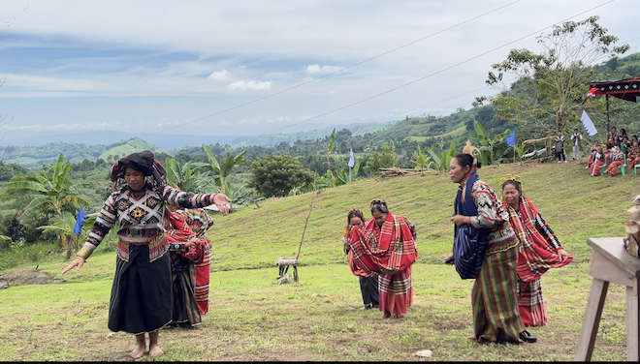
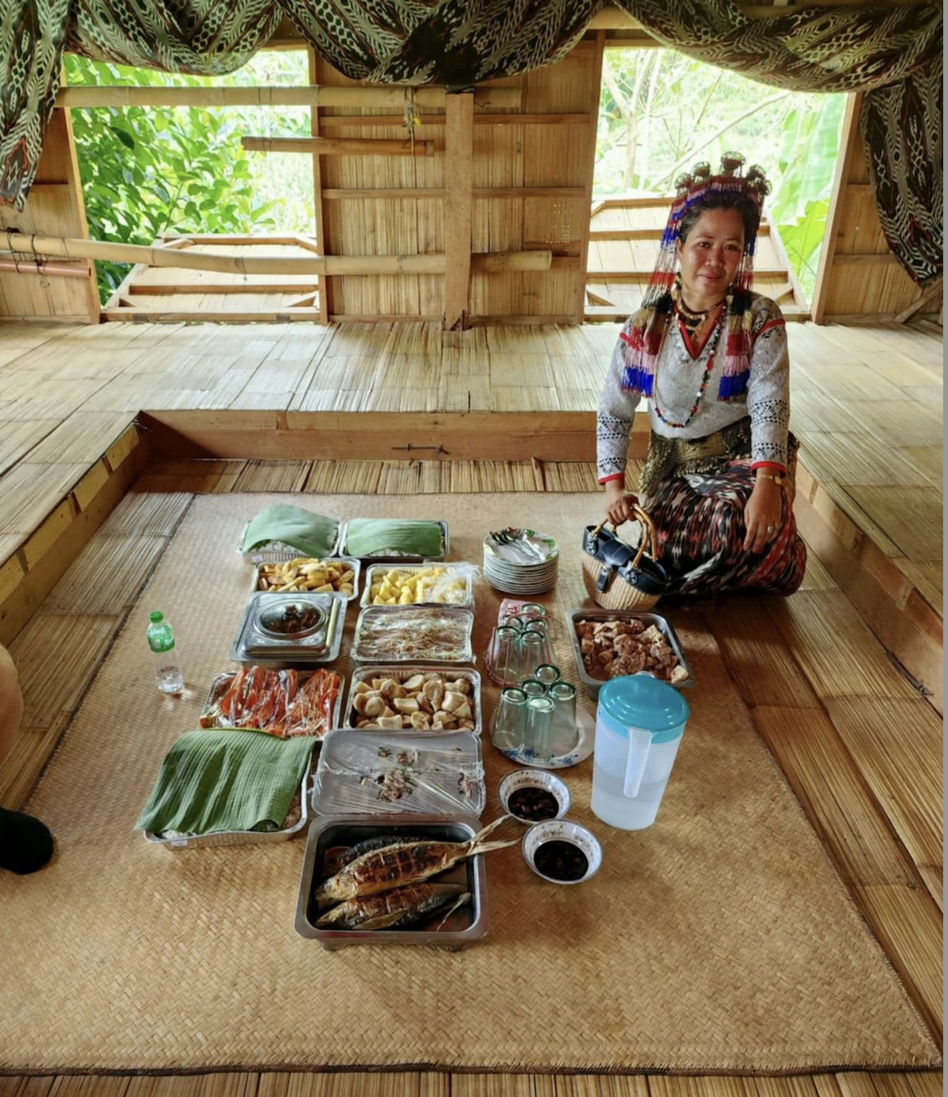

Lunch was prepared by the Ken Kemdaw (Food Committee) with traditional Tboli food sourced from the local areas. Lunch consisted Kem ken béléte (indigenous food); Ken hnunges lemenge/lenobung (food/rice wrapped with lemengé/lenobung leaf) , nelut (rice/viand cooked in bamboo), tnétê/dnolong (grilled), keteng snobow (fresh water shell soup), onuk snobow (chicken tinola), prito kefeya (fried fish tilapia).
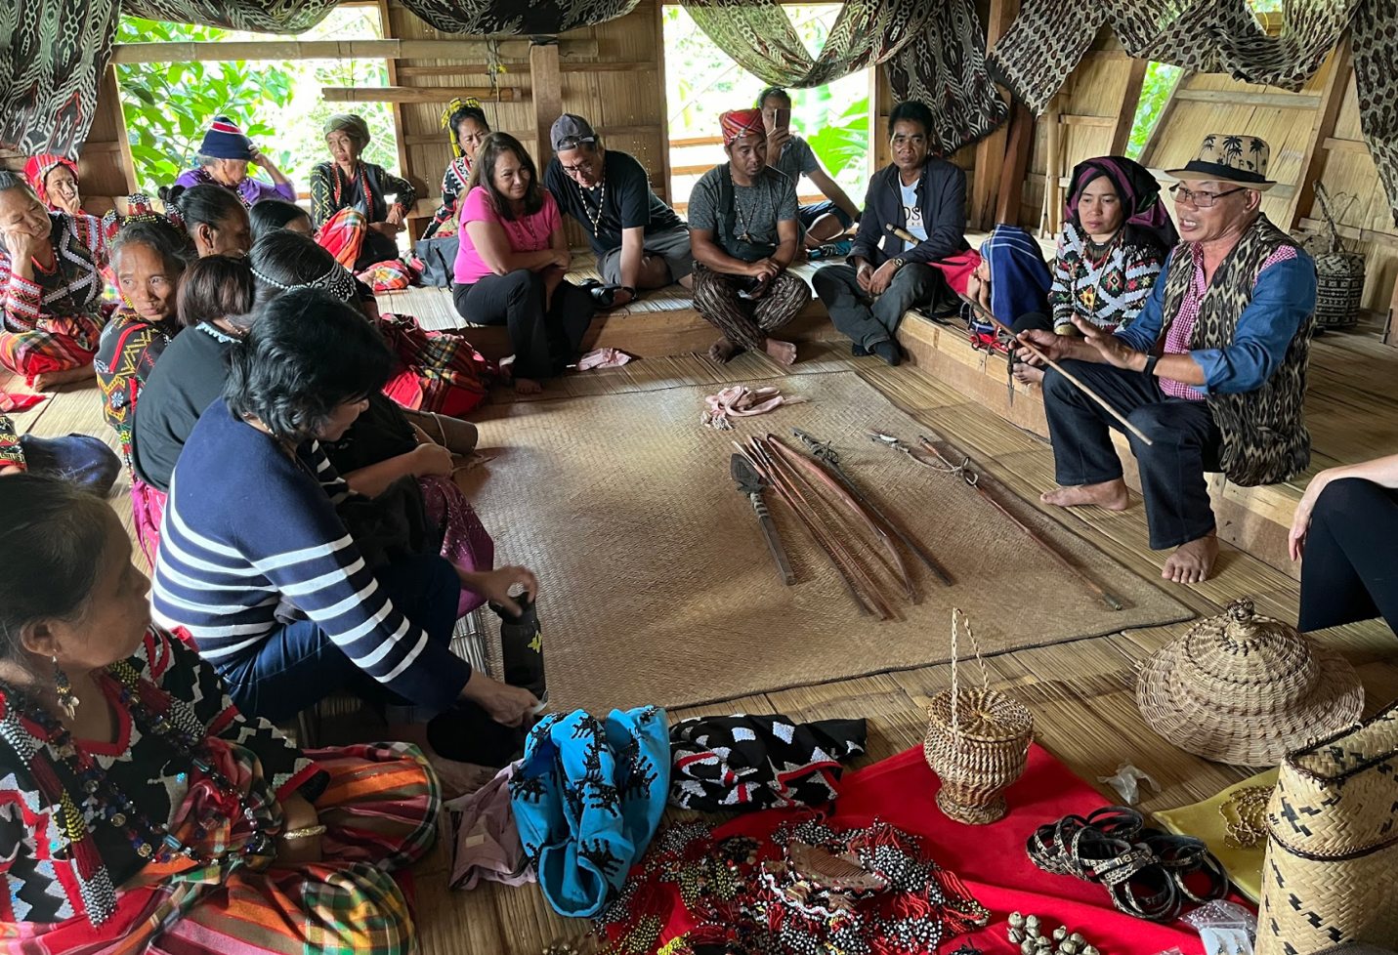
Storytelling continued with Boi Myrna B. Pula & Mechie Belleza. In one of the sessions, Mr. Johnny Sumugat. Retired Regional Education Supervisor of Department of Education Region XII, and an Indigenous Peoples Education-IPEd focal person presented Gono his own personal collection of Tboli spears and bamboo hunting weapons. In the spirit of “Tulus Kimu” which Boi Myrna Pula explained as the “spirits of Tboli heritage objects” calling to each other to go back to its homeland – Mr Santos presented the collection as a gift to the Storytelling house to further increase its collection and the basis for even more storytelling.

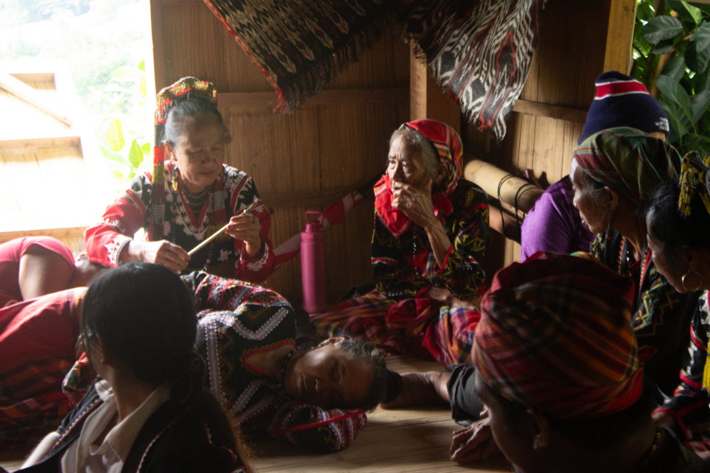
Boi Myrna recounted that this calling, which she thinks began with the return of Billlie Riley’s collection, has also made other Tboli elders and acquaintances give back Tboli artefacts for safe keeping and cultural studies at the Tboli Gono. A two-hour break for rest and an early dinner. The Festival went through the night (after dinner together) from 7:00 PM to 11 PM.
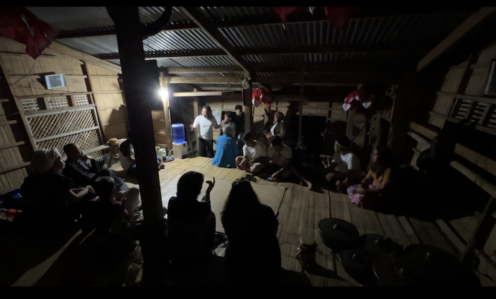

There was a brown out but this did not stop the festivities. The Tbolis insisted on epic chanting at night according to remembered tradition. Nightime is seen as a time of quiet and rest from the work in the farms during the day. The Keselingon (chant) was led by Datu Dodong Ulaw and Boi Selya. There were constant shouts of encouragement and admiration from the audience to help keep the chanting going.

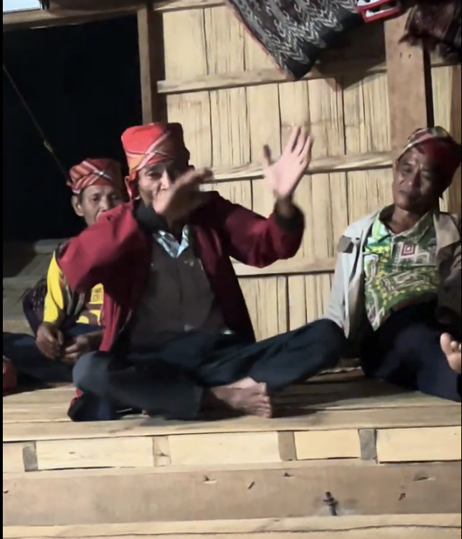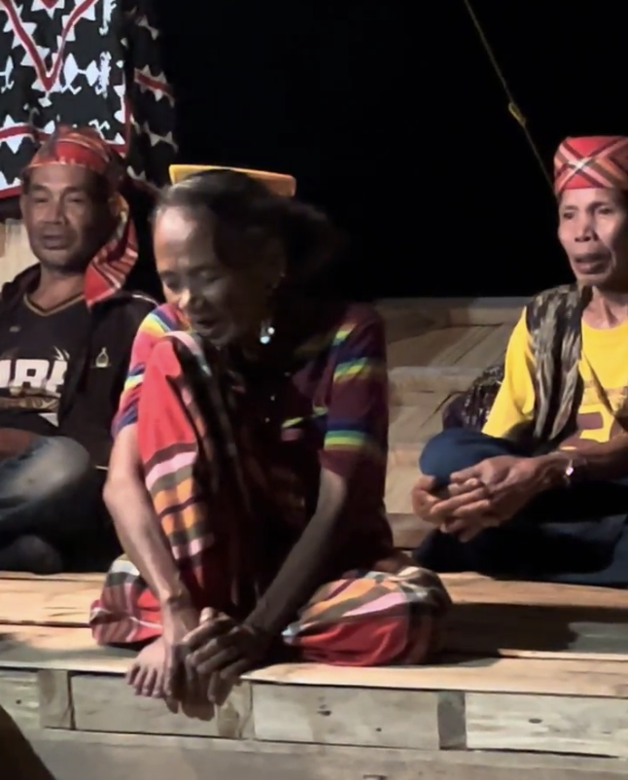

DAY 2

The day started early again, with breakfast ay 7:00-8:00am. A very significant event followed: the Demsu: Nungkul nóen Mdà Gónô Tmutul/Ground Breaking/Inaugural Blessing.

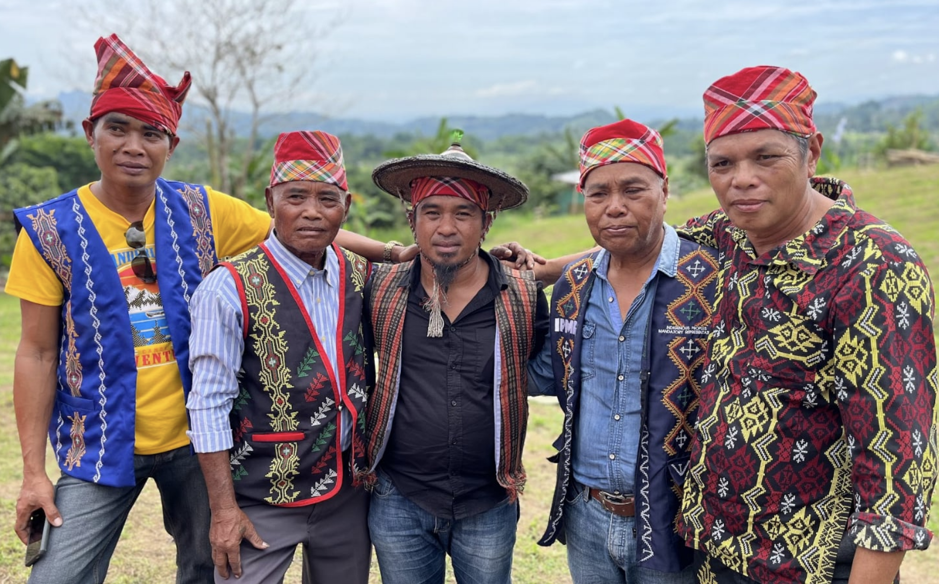

Kamagi (or Gear beads maker) Dodoy A. Kasi (Ritualist), Datu Simeon Paran (Municipal Indigenous Political Structure-member and Lead Ritualist), me, Datu Ramon Mann (indigenous Political mandatory Representative -IPMR of Brgy. Lake Seluton), and Datu Toyong Alon(IPMR of Brgy. Bacdulong).. Ritualist

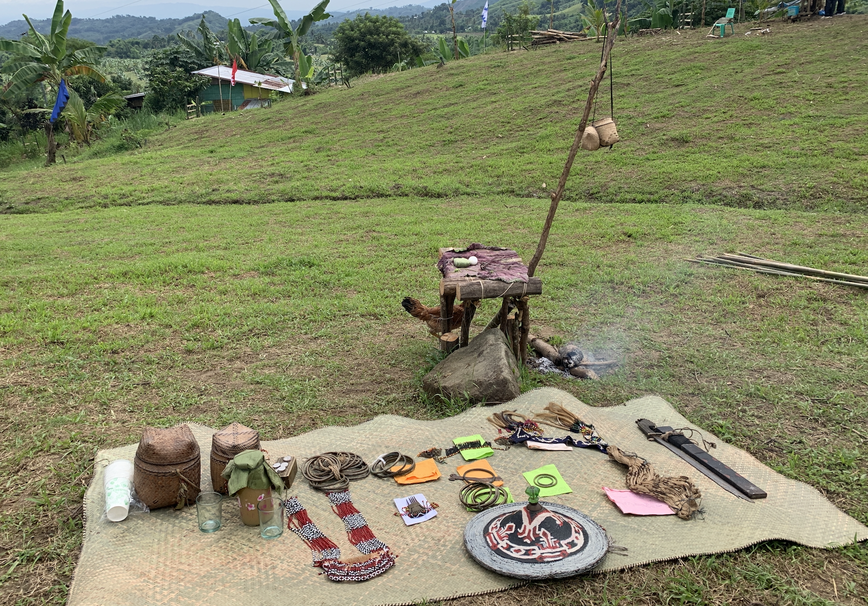

The ceremony began with laying out the ritual elements at the Gono mahan ( ritual architecture) with Datu Toyong Alon calling on the spirits of tangible material culture to bless the project. He named the spirits of each object:

- Kem desu: filak, kegal, kefilan, tnalak
- Onuk bukay/fatu
- Ongu, kuleng tonok, ofi, el
- Kotong/bewol ne sedangon

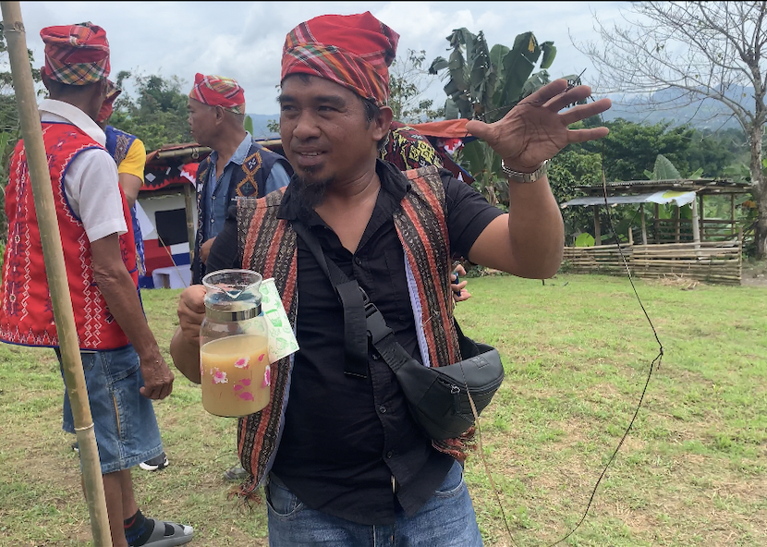
A ritual test was performed with with four datus and Benjie Manuel. The datus buried the middle sections of four separate strands of abaca in the ground, leaving the ends of the strands exposed. Benjie was then asked to tie these exposed ends together randomly. After removing the strands, the resulting pattern was examined to assess its significance for the construction of Gono Tmutul.The result was a perfect circle, which was a rare and significant outcome for these ritual tests. Typically, the results might show two separate circles or various disjointed shapes, but the perfect circle formed by the strands was seen as a very positive sign, suggesting future unity and blessings.

After the highly emotional celebration after the groundbreaking rituals, a workshop on story Book Development along with Artefacts/Kehegefan ne ketutul kem kimu Hulek Boi Fak/kem dumu tau mlay kimu was done with Marian Pastor Roces, TAOINC, and Maria Cristina Juan, SOAS, Children, Youth and Elders. We discussed a way forward for the creation of educational materials for Phase III of the project.

Communal lunch followed Ken Kemdaw/Lunch (Food Committee Precybell and volunteers)

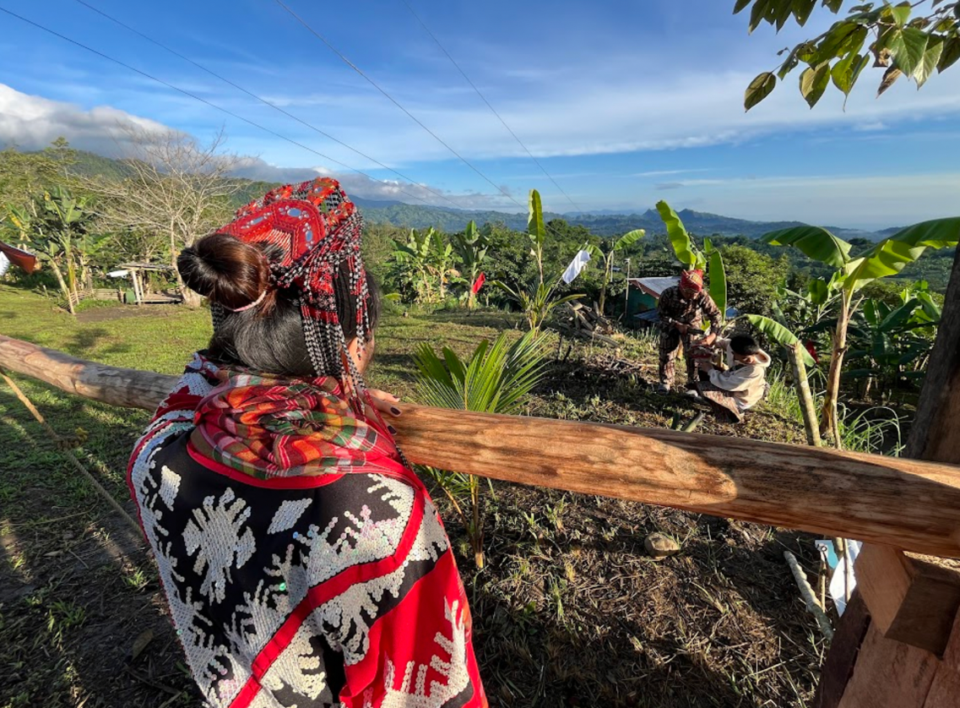
The afternoon programme began with a tree-planting session, where saplings of endemic trees were planted around the acreage.

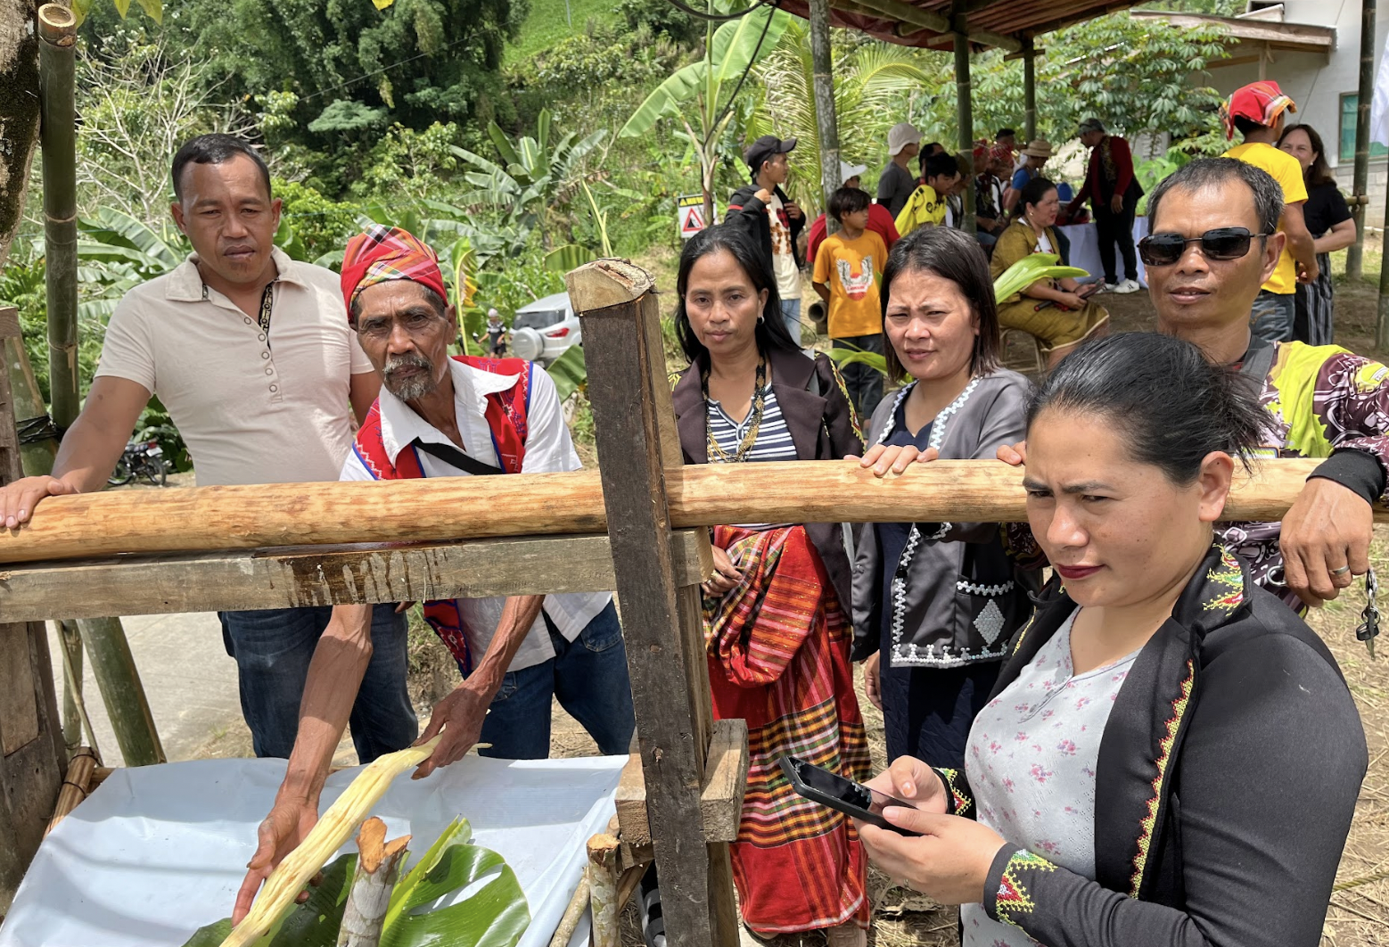
A recreation of a Tboli local sugarcane crusher used to make the ritual drink used earlier in the groundbreaking ceremony.
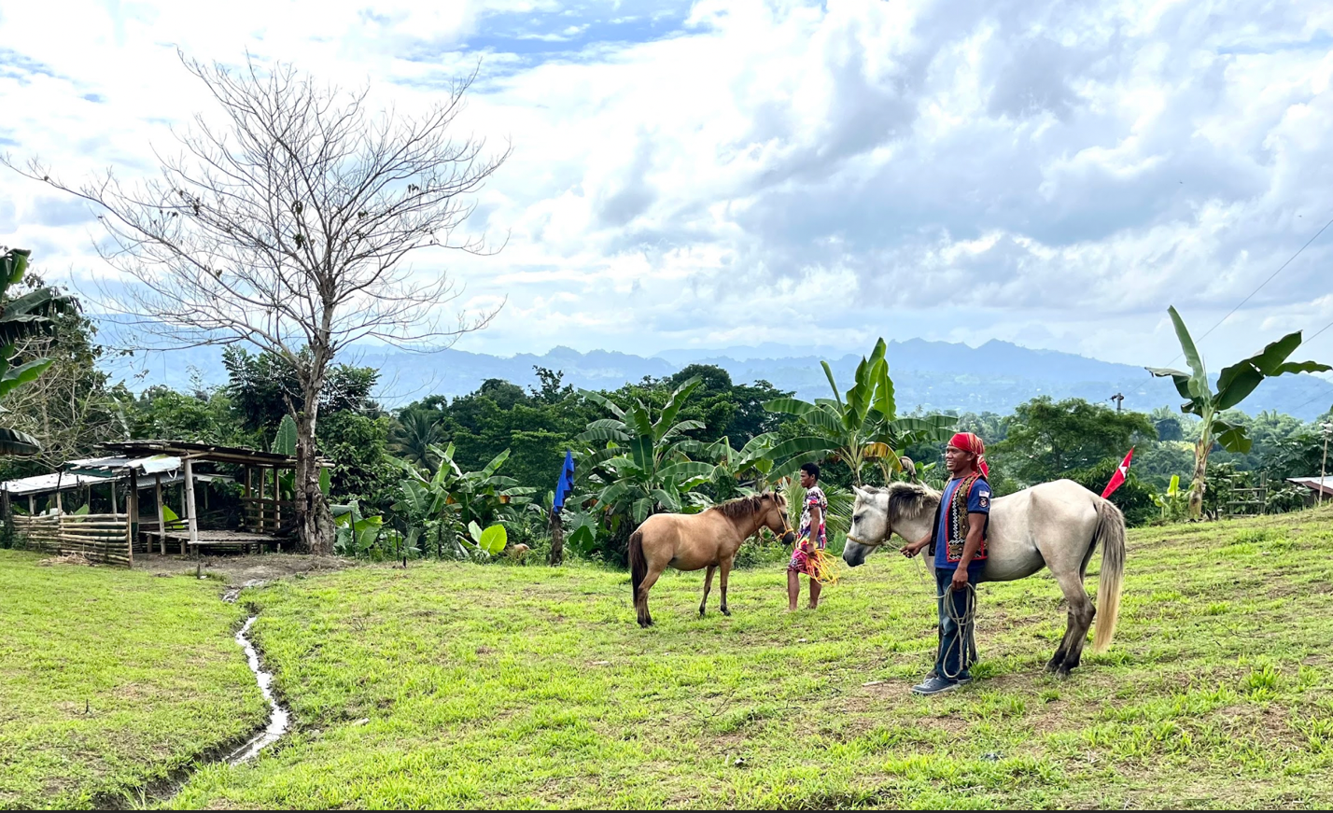
Right after, there was a revival of what many Tbolis consider as one of the most beloved parts of Tboli gatherings: horse grooming and equestrian performances.

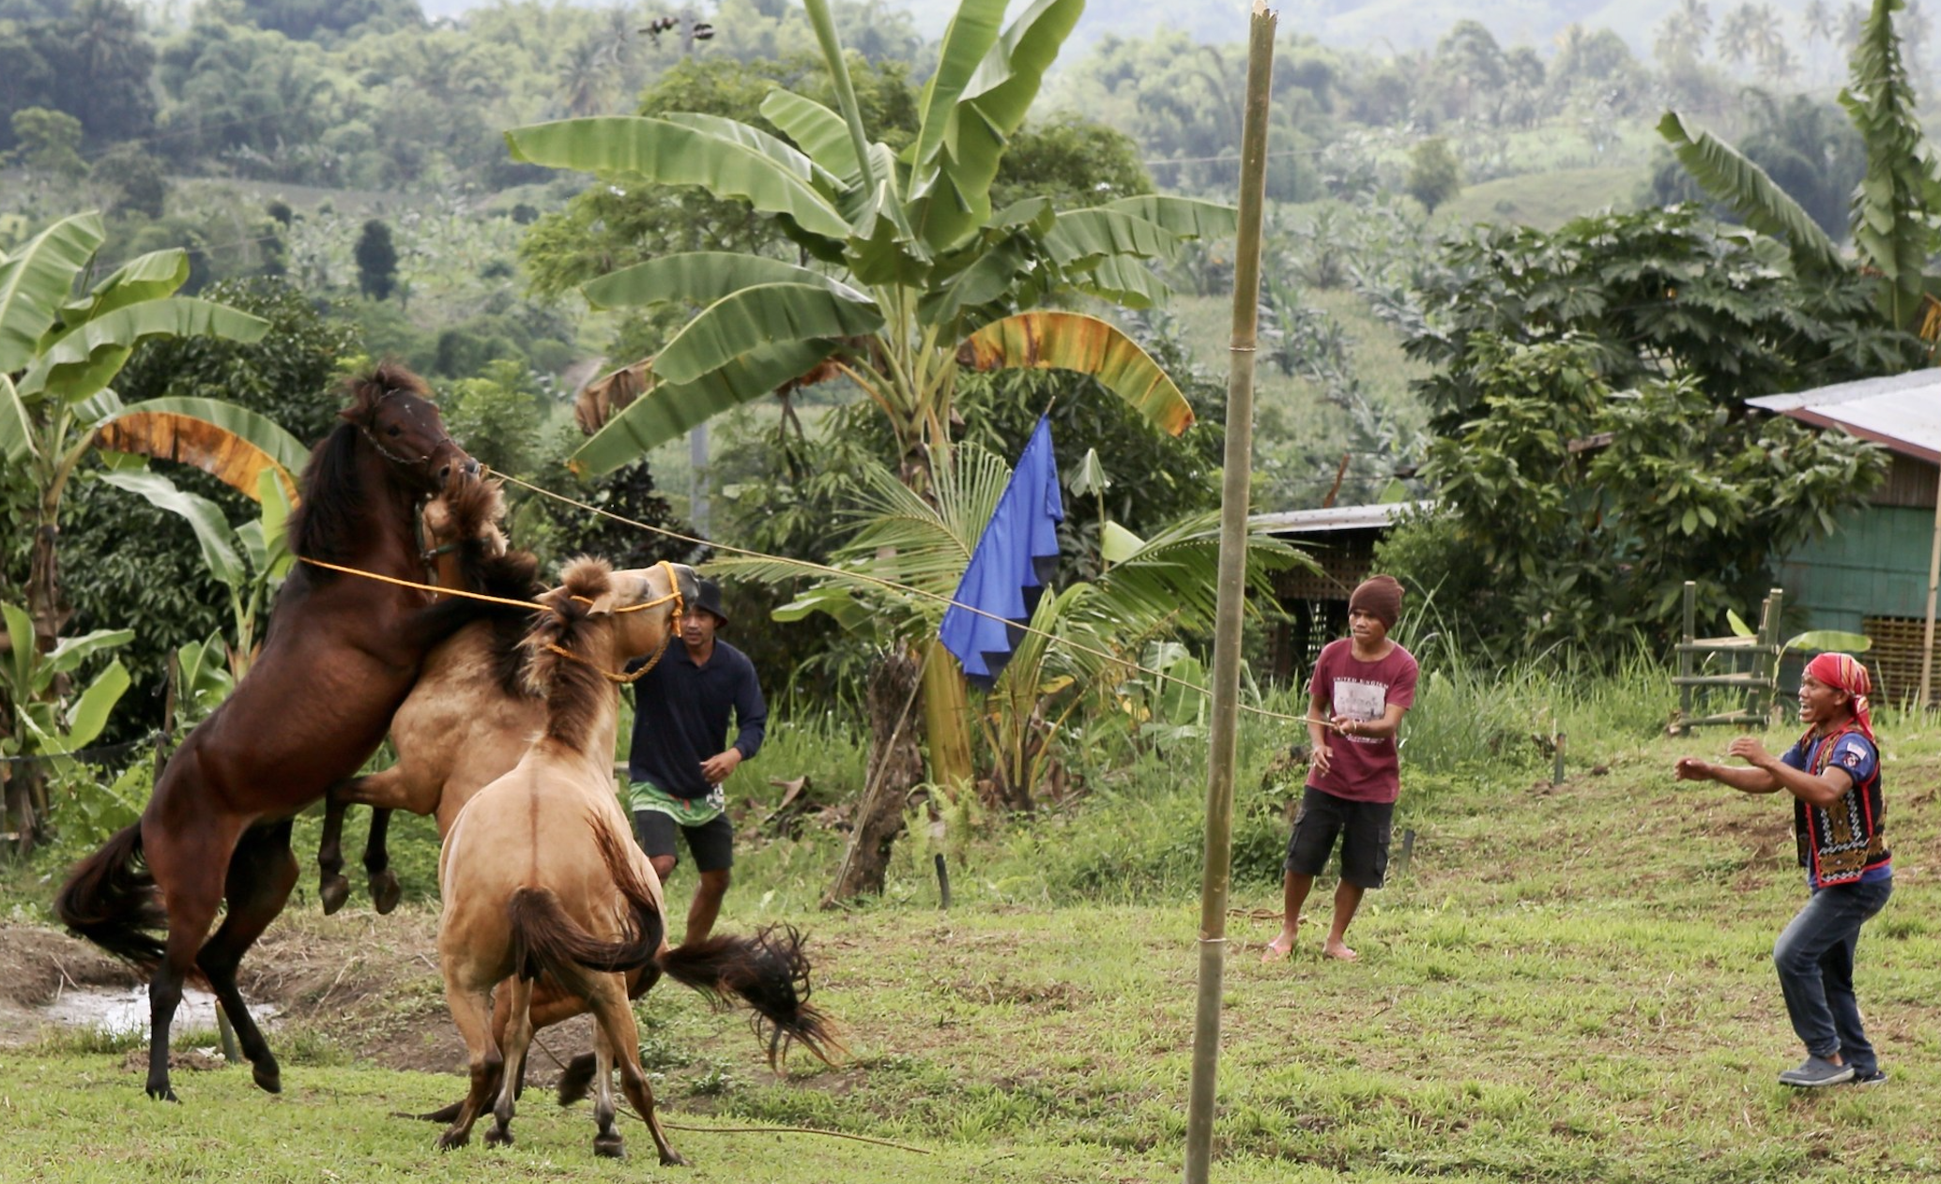Once done every time there were Tboli weddings in open air wedding rituals (Casal, G. S. (1978). T'boli art in its socio-cultural context. Makati: Ayala Museum.) the “horse fighting” section was met with screeches of enjoyment and excitement from the Tboli children and youth who have not seen this performance in their lifetime.

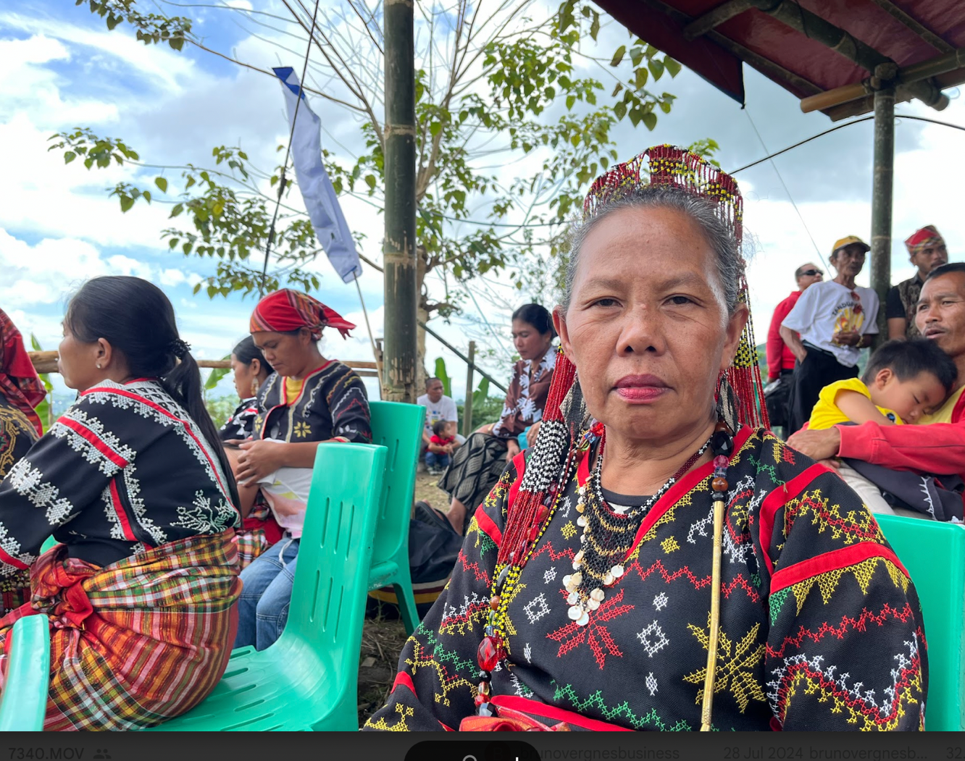

A closing Program (Kdeng Kesegayun Lemkuluhen) ended with prayers, Giving of Certificates/Tokens (Recognizing contributors and participants) and Closing Remarks (Hon. Roger A. Ben, Punong Barangay) and Acknowledgements by Benjie M. Manuel, Gónô Tmutul Caretaker.

Some takeaways from the conclusion of Phase I of the Tboli Storytelling Festival project

The Tboli House of Stories event was a profound celebration of Tboli culture, heritage, and community solidarity. Here are the key takeaways and analyses:

1. Cultural Reconnection and Preservation: The event successfully reconnected Tboli youth with
their cultural heritage through storytelling, music, dance, and artisanal workshops. This reconnection is crucial for the preservation of Tboli traditions in the face of modern challenges.

2. Community Engagement and Ownership: The active involvement of community members in both the planning and execution of the event fostered a strong sense of ownership and pride. The collective contribution of heirlooms to Gónô Tmutul underscores the importance of community-driven heritage preservation.

3. Educational Impact: The integration of traditional knowledge into the public education system, spearheaded by Benjie Manuel, is a model for other indigenous communities. This initiative ensures that Tboli culture is not only preserved but also passed on to future generations in a structured and sustainable manner.

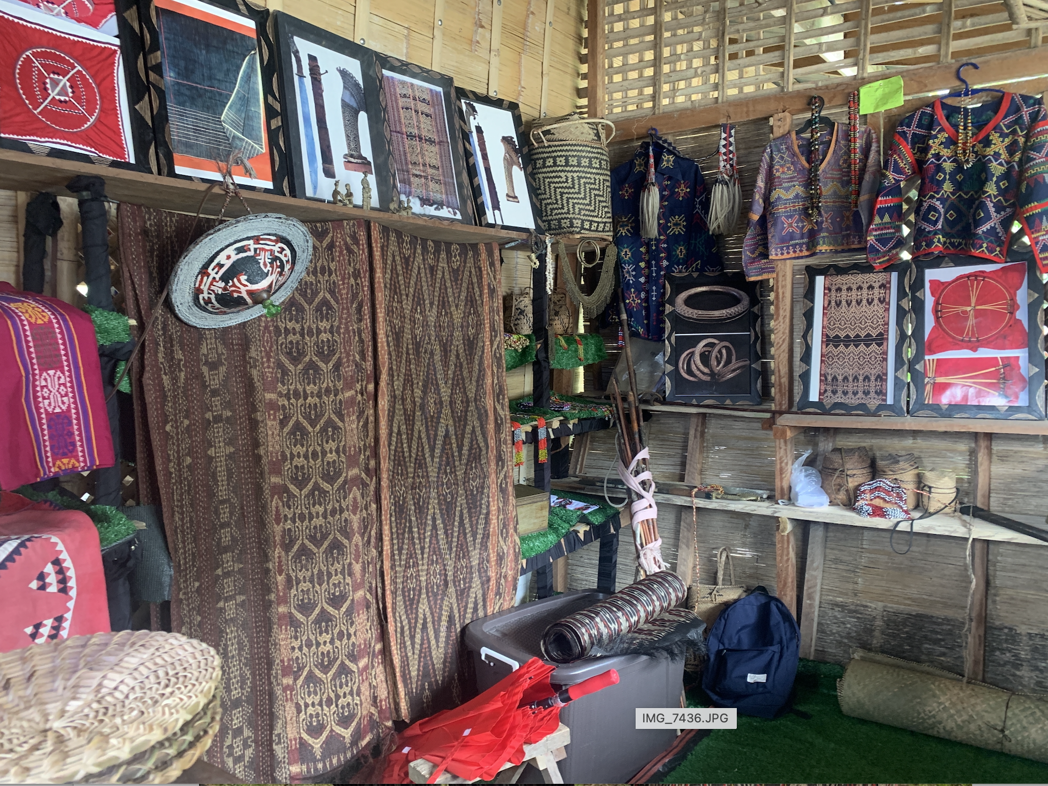

4. Re-creation of alternative forms of production for heritage techniques: The festival provided a platform for Tboli artisans, including ikat-dyers, brass casters, and beadworkers, to not only showcase their skills and gain recognition but also to imagine the possibility of creating a This empowerment is vital for sustaining traditional crafts and ensuring that these artisans are valued beyond being mere craftsmen. The institution of the Gono

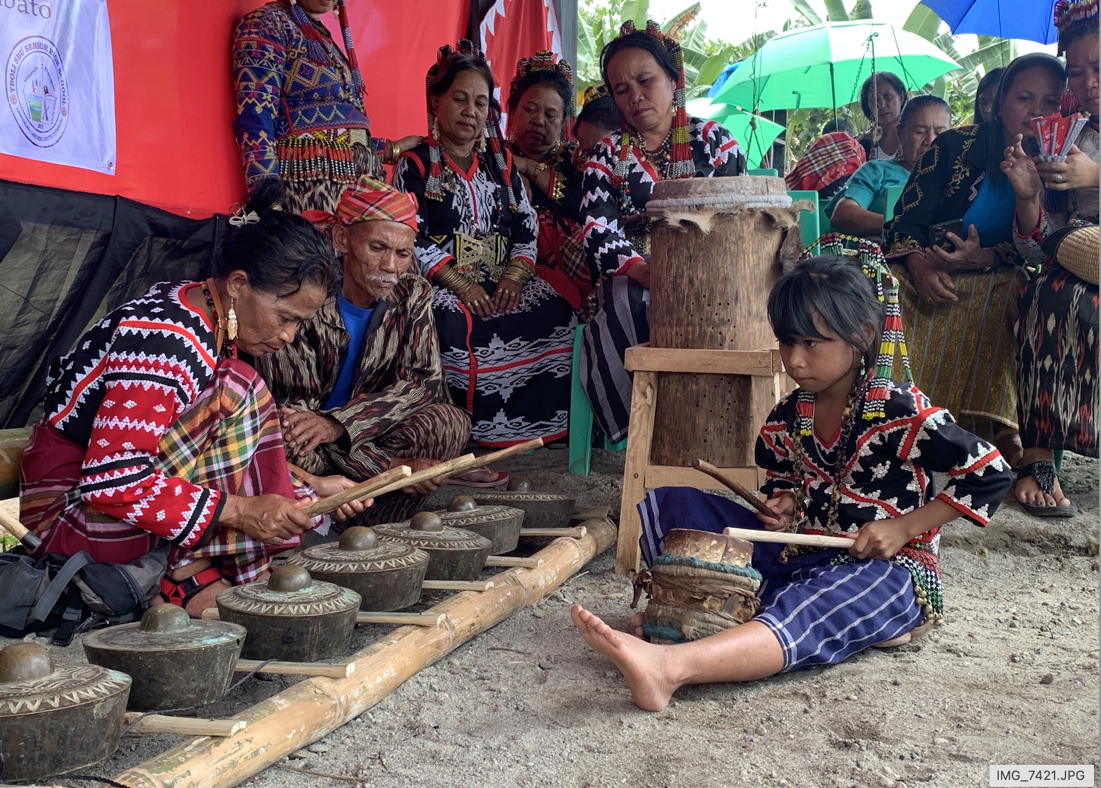

5. Multigenerational Dialogue: The interactions between elder storytellers and the youth fostered a multigenerational dialogue that is crucial for cultural continuity. The festival format allowed for the seamless transmission of knowledge and traditions across generations.

6. Local Impact with global implications: The event was designed specifically for the Tboli – and not for external audiences but its execution did attract global audiences, including tourists, government workers, academics, and international artists. This diverse engagement highlights the global relevance of local cultural initiatives and the potential for broader cultural exchange and understanding but specifically in the Tboli’s own terms. The youth of Lake Sebu and other Tboli villages; and, by extension, the youth of language communities neighboring the Tboli and their interaction with elder performers and makers of material culture will be circular, in that dialogue will inform the creation of books for children after them.

The festival laid a good groundwork for Phase II which will be ongoing workshops that would include private and public school teachers who may wish to collaborate with Gónô Tmutul's curriculum-in-progress.

It also leads to Phase III of the project which will be a SOAS seminar that will engage academics, global civil society, international circuit artists, and potential future funders, in navigating the ethical thickets of materials and knowledge transfer. It will also funnel into The SOAS database project, "Mapping Philippine Material Culture Overseas," where the narratives of this return and its consequent community-led spaces for heritage revitalization will also reach its already remarkable audience, which counts museum directors and curators in global capitals who are typically interested in developing relational ties with source cultures of their collections.

7. Future Directions: The project's success for Phase I sets a precedent for similar initiatives among other indigenous communities in Island Southeast Asia.

As a direct result of the Festival, further funding for similar storytelling festivals among the Tboli was raised. A well-known architect based in the Philippines heard of the Festival and volunteered to conduct a community-led workshop to be conducted on August 17 -19, 2024 - which will be the second gono tmutul storytelling event. Architect Sudarshan Khadka (https://www.tatlerasia.com/people/sudarshan-khadka-jnr) will meet musicians, carpenters, bamboo experts, etc. to co-design the actual structure of the storytelling house. There will be music in order to understand the use of a Tboli house as a musical instrument. Benjie Manuel will again invite epic chanters and instrumentalists and the event, while a more modest session unlike the launch. Benjie Manuel will document complete house design development and may be used for architecture students.

The integration of architectural, museological and archival work with grassroots empowerment can serve as a blueprint for heritage preservation and cultural revitalization in other regions.

Some Conclusions

The Phase I of the project (the Festival proper) had a targeted demographic, helping Tboli youth mingle with ikat-dyers, embroiderers, brass casters, and beadworkers who can be strengthened in their struggle against diminishment into mere "craftsmen" or "artisans" as they were refamiliarized with Tboli epic traditions Among the youth is an expected sub-set who are trying to be artists in contemporary idioms, typically interested in tradition. They will be given close views of complex old versions of virtuosity in material and performed forms, so that their references for life will be intact rather than eroded forms.

The festival format, an exercise in collaborative project design, was a good model of public programming that does not prioritize external audiences - even if an external audience is always invited and welcomed. This approach will be an important counterpoint to Philippine cultural work in general, which is typically projected outwards, with indigenous peoples performing as exotica.

The implementation of this project provided insights to similar situations/contexts in Island Southeast Asia. The Tboli situation finds broad similarity: a heretofore small-scale culture of shifting agriculturists who have been settled by missionaries and national government within the last half-century or slightly more; loss of artifacts to major museums in the Euro-American world; their vulnerability to cross forms to tourism and "product development"; and their desire for reconnection with ancestral knowledge.

If the Gónô Tmutul project formulation - that integrates museological/archival work with grassroots self-empowerment agenda - succeeds, then it may positively inform similar initiatives among the Sarawak Iban, Timor Leste's Tetum, Sulawesi's Toraja, Sumba's Kambera, Flores' Lio, Manggarai, and Ngada, and so forth. These are island SEA's ikat-dyeing cultures, which are also known for their epics and strong narrative performances. Such positive contribution will be in: a) the design of tracks from tradition to contemporary life, without loss of complexity as much as possible; and b) the ways to reconnect material and intangible traditions by close attention to languages of storytelling.

