Borrowing Songs, Lending Voices
Encountering Ainu through the online teaching and learning of upopo: a reflexive case study

George Nummelin
SOAS
Department of Music
129513@soas.ac.uk

Introduction

In this presentation, I’m sharing some of my experiences in introducing Ainu songs to a Japanese folk song group that I’m part of, the SOAS Min’yo Group (SMG), during the UK COVID-19 lockdowns. We had planned on doing this for a while, but as I wasn’t able to go to Japan to continue my PhD fieldwork, it also gave me an opportunity to conduct some reflexive ethnography. I was interested in exploring what it was like to teach Ainu pieces to non-Ainu, and non-Ainu speakers, and how effective transmission could be online. There were aspects that went smoothly, but there were also issues that arose in terms of navigating remote music making, and in terms of how to ensure that we approached this broadening of our repertoire with respect and sensitivity to the Ainu peoples whose songs we were singing.

NB: My original abstract did state that my paper would also cover my work in introducing Ainu songs and language to a group of students at my school, but timetable and staff changes made this impossible sadly.

Who are the Ainu?

The Ainu are an Indigenous community, now mainly living in Hokkaido and Tokyo, but previously also inhabited the Kurils, Sakhalin, and parts of northern Honshu. Their language is a spoken language isolate, and due to the effects of Japanese colonialism, is now critically endangered, although there are revitalisation efforts taking place – mainly in Hokkaido.

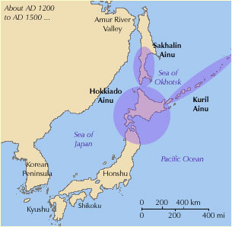
Figure 1 Historic Ainu settlements

The SOAS Min’yo Group

The SOAS Min’yo Group (SMG) is a group that learns and performs min’yo, which are Japanese folk songs. We have a mixture of singers, percussionists, shakuhachi, flute, and shamisen players. The group is diverse in its membership, with singers and instrumentalists from Japan, the UK, Italy, Greece, and the USA, and brings together absolute beginners, seasoned amateurs, and professionals. Our youngest member is in secondary school, and our oldest member is in their eighties. The levels of Japanese language and cultural knowledge are also broad and varied.

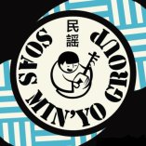
Figure 2 SOAS Min'yo Group Logo

The group was formed out of a Min’yo Summer School which was held at SOAS in 2012 and led by Dr David Hughes. Since then, wev’ve grown in size and reputation, leading to frequent performances across the UK, and we’ve even performed at Copenhagen’s Sakura Festival several times – the potential to include Ainu music in our performance repertoire was therefore in place.

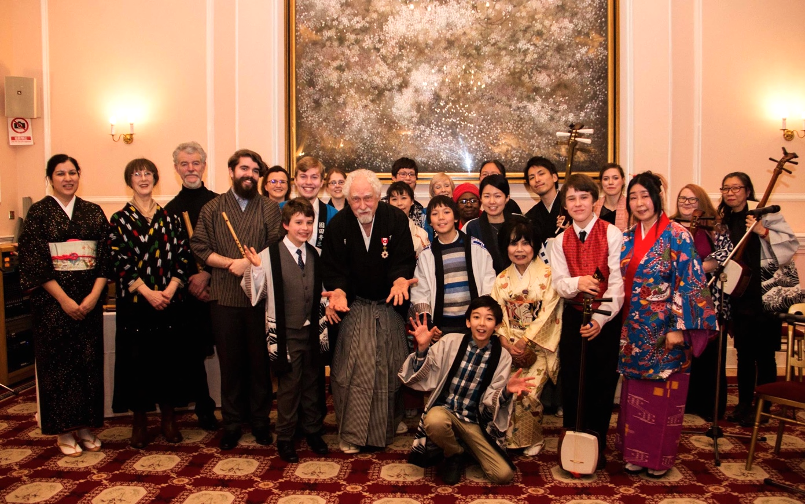
Figure 3 SMG at the Japanese Embassy, 2018

Ethical Concerns

In undertaking this as a long term (reflexive) ethnographic study, and not merely as an opportunity for musicking, I had to give due consideration to how I would position myself, my methodology, and the ethics. Aull Davies makes a valid point in her 2008 work, Reflexive Ethnography: A Guide to Researching Selves and Others, that ‘the disembodied nature of internet interactions, and hence the lack of access to the information that physical presence may convey, cannot be fully compensated even by the most technologically advanced sites’ (180). This is certainly true to an extent and is one of the potential pitfalls of relying solely on web-based ethnography, particularly in the context of websites. However, with the availability of free web conferencing tools, there is a possibility to mitigate some of these issues. Additionally, in this context, I rehearsed and performed regularly with SMG, and therefore have an additional understanding that may not be present in a traditional researcher/researched relationship. SMG members are friends, colleagues, and good acquaintances - I already knew that they would be both enthusiastic and respectful. I did however, continually (and do even now) consider how to do this ‘the right way’ – in rehearsal, and in any potential future performances (particularly when time doesn’t necessarily allow lengthy discourse about the importance of these songs, their place in the Ainu world, or the ethical complexities of having a *Japanese* music group singing these songs): these are not our songs, and not our histories.

Resource Collection and Creation

Having decided to expand our repertoire, the next stage was to create appropriate resources, with care and consideration to the Ainu tradition. As such, discussion with colleagues of Ainu heritage, including contextual information, and attributing recorded versions of pieces played their part in the process.
In terms of song choice, I drew on my experiences as a teacher, and a musician: what (partial) resources I had, what would be easy to deliver remotely, and the ability of the group for example. So, the decision to use upopo as the introduction to Ainu music, language, and culture, was an easy one: domestic and seated songs, not challenging to learn melodically, or to recall lyrically, and therefore an ideal genre of Ainu music to begin with.
Upopo are secular songs and there are no issues regarding when and where these songs are performed, although the majority would have been sung by women and children rather than men. However, there isn't a taboo about this.
I chose the songs Pirka Pirka, Ikamukka Sanke, and Itasankata. Pirka Pirka is perhaps one of the best known Ainu songs, and like many upopo, can be sung solo or in canon . I picked as our first song due the potential for others to have heard it, and because pirka (beautiful, good, well done) is one of the most commonly seen Ainu words. It is also a pentatonic melody, and while min’yo are not purely pentatonic, the tonality is similar.

Pirka Pirka, Beautiful, beautiful
Tanto sirpirka Today is a beautiful day
Inaan kur pirka, Who do you like?
Numke kusne. Let me choose.

Figure 4 Pirka Pirka lyrics, with translation
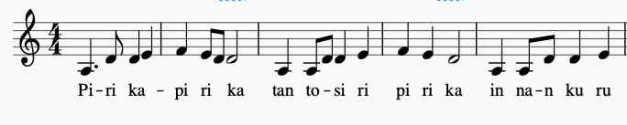
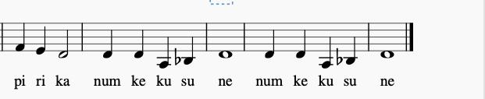
Figure 5 Transcription of Pirka Pirka
Ikamukka Sanke was my second choice. It can similarly be sung in canon, offering an opportunity to extend an otherwise short piece into one that can also sound more complex for performance purposes.

Ikamukka sanke e-i sanke e-i san na. Get the lid off. Get it off. Now it is off.

Figure 6 Ikamukka lyrics, with translation
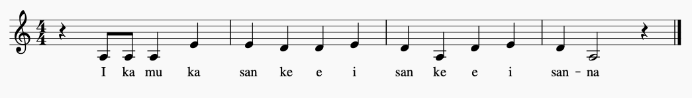
Figure 7 Ikamukka transcription
The third song, Itasankata, sings about shintoko (lacquerware storage barrels), was chosen for no other reason than my enjoyment of it: the lyrics mention the shintoko shaking on the altar, and when sung in canon, the polyphony seems to mimic the movement of the shintoko.

Itasankata kaniponkuto sintoko
heretun retun, heretun chari.
A small beautiful shintoko (lacquerware barrel) with sashes is shaking on the altar.

Figure 8 Itasankata lyrics, with translation
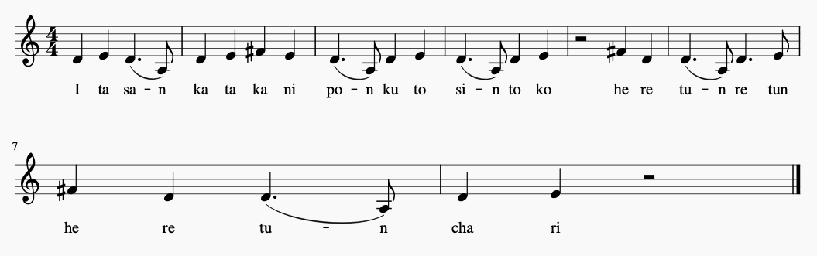

Figure 9 Itasankata Transcription

Like many upopo, transcriptions and lyrics are challenging to find, as are any translations, so I transcribed the three pieces by ear (badly…), listening to recordings I had on CD (Marewew 2012, Ando 2011, and Kapiw & Appapo 2016) and to recordings and performances I found on YouTube, such as on Sekine Maya’s Sito Channel.
I had to mainly use my own scant but growing knowledge of Ainu to translate the songs, aided by any descriptions that accompanied the recordings. I translated them into English as not all of our members speak Japanese, and it would also widen understanding if, and when we performed them live, as we tend to offer explanations of the songs, and often display the lyrics. This reliance on my own Ainu skills, however, did worry me. I was wary of making mistakes, and worried about how to incorporate songs with more complex lyrics. Sometimes, however, luck is with you, and I made a fortuitous find one night when sleep was evading me, discovering the paper Appreciation of Ainu poetry: Focusing on rhyme (Tangiku 2018) which contained both lyrics and Japanese translations for many upopo, saving me a great amount of time and frustration.

Teaching and Learning
As anyone trying to rehearse over the internet knows, one of the biggest issues is the time lag that occurs, regardless of how fast or stable everyone's internet connections are. We had done a lot of experimentation in the lead up to the 2020 Japan Matsuri, where we perform each year, in an attempt to record us performing as an ensemble. We quickly learned that it was nigh on impossible to all sing/play together, and so for rehearsals, we moved to a model where one person would lead, and others would perform with their mics off, so we were at least able to sing/play out loud in our own homes in time with the speed of the feed. I ended up producing videos compiled of footage from previous performances, footage from our rehearsals online, and splicing everyone’s solo recorded vocals together. We then took this approach for our online rehearsals of our Ainu repertoire.

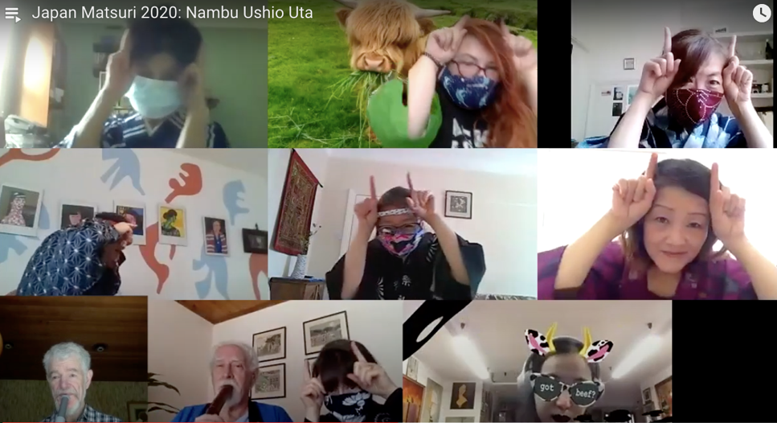

Figure 10 Still from Nambu Ushioi Uta, an ox herding song

As mentioned before, our group is quite diverse, and not everyone knew much about the Ainu, so I began by explaining who the Ainu were, some of the issues they had experienced, and were still facing, and my reasons for wanting to include Ainu songs in our repertoire: as part of my reflexive ethnography, to make our repertoire more inclusive, to support the transmission of Ainu language and culture, and because, quite simply, representation matters. I wanted this to be a case of us lending our voices to the Ainu communities, to disseminate Ainu songs and culture, and to increase awareness of Ainu culture to both Japanese and non-Japanese audiences. The group’s response was completely positive – sensitive with questions, and soon people were sharing their own Ainu music and language discoveries (recordings, articles and so forth) with each other, and suggesting new Ainu songs to learn.

Music for All
Within the SMG we have a mixture of musical abilities - much like a typical secondary school music class, expect that there are no battles with apathy or behaviour! Resource and repertoire accessibility is therefore important to give everyone a role. I wanted to teach upopo in context, as part of an Indigenous tradition that is a living and ever-changing culture, and as part of an effort to increase visibility and understanding of Ainu culture specifically. Additionally, I wanted to teach in a way that could be replicated by Ainu and non-Ainu alike, and by professional teachers and/or musicians, or those who merely had an interest, and these resources were a starting point in this process.
Teaching by rote would be the traditional method both for the Ainu songs, and for min'yo, however, there are benefits to using staff notation, even for those who cannot read it, so I roughly transcribed the upopo. Staff notation would aid those who can sight sing, or those who might want to play the pieces on an instrument, those who cannot read the notation would still have a visual to follow, showing the shape of the melody, and finally, because it would ensure that people could still have a guide for practicing along. Naturally, the staff notation is only a guide; the singer is free to sing the piece in any key, and this is a point we return to frequently, that notation can potentially ‘discourage the creative variation that is so often considered part of an authentic performance’ (Bithell 2014) if seen as definitive as opposed to facilitative.

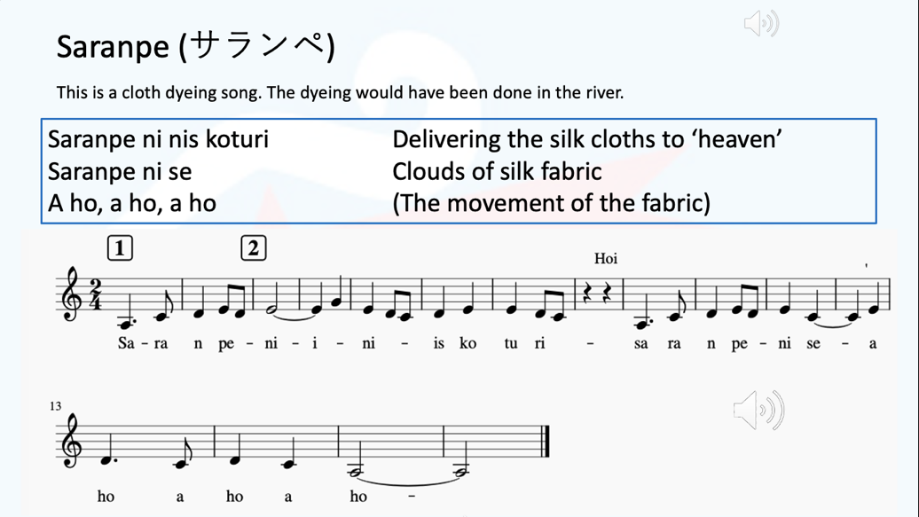
Figure 11 Saranpe PowerPoint slide
I embedded audio recordings into the presentation for each song so learners could hear the song itself, and also the way in which the songs are sung. The traditional vocal timbre is often very different to the way non-Ainu may sing, much like the way in which min'yo are traditionally sung, with a harder, and somewhat more nasal timbre. I also recorded myself singing the songs as a reference.

Figure 12 LogicPro X recording of Saranpe parts

Conclusion
As this is an ongoing project, in which I would like to see Ainu songs form a permanent part of our repertoire (with the potential later for the addition of the tonkori and mukkuri), any conclusions refer only to a snapshot of this broader venture. What is more, this is a snapshot taken during curtailed fieldwork, and in lockdown, due to the COVID-19 pandemic. However, that does not detract from the inherent importance or validity of the process, or the outcomes: digital ethnography is now a standard part of many research projects As such, I could comfortably apply similar methodologies to both situations, and Hine’s views on embedded internet resonated with me. Hine recalls that ‘Cyberspace was construed as a domain apart from everyday life, imagined as offering up new possibilities for pioneering developments, separate from prevailing modes of governance and potentially free from enduring structures and inequalities experienced in “real life” settings’ (2020: 43), but that embedded internet had changed that to a large degree: increased connectivity on consoles, pads, and particularly phones, had deconstructed the barriers between one’s offline and online life. While our online lives may be lived and experienced somewhat differently, there is, for many, less of a disconnect than there once was, and online life is as ‘real’ as ‘real life’. In the context of our SMG rehearsals, the very existence of online life allowed ‘real life’ to continue, being able to meet and rehearse together as we usually would in real life, with online life making that possible, despite being spread across the UK, and even the world.
As we moved forward, with restrictions lifted, enabling the SMG to rehearse and perform together again, the successes for the SMG are clear, with the group beginning to sing the upopo more confidently, and with contextual knowledge, and keen to learn more Ainu songs to include them in our repertoire. The group are also incorporating some songs into the setlists for a number of upcoming performances.
There are of course issues which require continued consideration: an undercurrent of concern about trying to meet the demands of transmitting these Indigenous songs, with care, accuracy, and appropriate context, without turning each session into a lecture on Indigenous rights, decolonisation and activism, was, and is, ever present. Additionally, while we found ways to work around geographical, time, and government imposed barriers, this doesn’t provide a cure all for the barriers faced by Ainu communities in (re)creating or (re)claiming Indigenous space, where cultural, musical, and linguistic traditions can be revitalised and shared, or where Indigenous activism can take place. The SMG has an inherent privilege and access to platforms that many Ainu do not, and it is crucial to recognise that what we do is not activism. We can, however, use that privilege to broaden knowledge about historical and contemporary Ainu Indigenous identity and customs, and perhaps that may, at times, have the potential to do some good. As such, as we continue to rehearse and perform Ainu songs, I will continue to refer to writers such as Tuhiwai Smith (2012) because even though I make concerted efforts to decolonise my approaches, it is an ongoing process, and one that is more complex in this context, where I introduced a colonised tradition to the SMG, which focuses on the songs of the colonisers. I need to ensure that I am ‘getting the story right, [and] telling the story well’ (Tuhiwai Smith 2012: 343), as we lend our voices to the songs (and by extension, the experiences and histories, of Indigenous communities) we are borrowing.

Bibliography
Anderson, W.M. and Shehan Campbell, P. (2010). Multicultural Perspectives in Music Education. Lanham Md.: Rowman & Littlefield Education.
Ando, Umeko. 2011. Ihunke. [CD]. Japan: Chikar Studio/Tough Beats
Ainu & Ainuic Heritage Education Society | Facebook. [online] Available at: https://www.facebook.com/groups/1930402067233811 [Accessed 26 Jan. 2021].
Aull Davies, C. (2008). Reflexive Ethnography: a Guide to Researching Selves and Others. Florence, UNITED STATES: Taylor & Francis Group.
Barz, G.F. and Cooley, T.J. (2008). Shadows in the field: new perspectives for fieldwork in ethnomusicology. 2nd ed. New York: Oxford University Press.
Bithell, C. (2014). A Different voice, a Different Song: Reclaiming Community through the Natural Voice and World Song. Oxford; New York: Oxford University Press.
Brown, M.F. (2004). Who owns native culture? Cambridge, Mass.: Harvard Univ. Press,
Etherington, K. (2004). Becoming a Reflexive Researcher: Using Our Selves in Research. London: Jessica Kingsley Publishers.
Graham, L.R. and Glenn, P.H. (2014). Performing Indigeneity: Global Histories and Contemporary Experiences. Lincoln: UNP Nebraska.
Hine, C. (2015). Ethnography for the Internet: Embedded, Embodied and Everyday. London, UNITED KINGDOM: Bloomsbury Publishing Plc.
Iji, T. (2018). Ainu Poetry Appreciation: Alliteration and Rhyme., Sapporo, Japan: Centre for Ainu and Indigenous Studies, Hokkaido University
Kapiw & Apappo. 2016. Paykar. [CD]. Japan: Independent release
Marewrew. 2012. Motto Ite, Hissorine. [CD]. Japan: Chikar Studio/Tough Beats
Natural Voice Network (2021). About – Natural Voice Network. [online] https://naturalvoice.net/. Available at: https://naturalvoice.net/about [Accessed 9 Jul. 2021].
Ndlovu, M. (2019). Performing indigeneity: Spectacles of Culture and Identity in Coloniality. London: Pluto Press.
Sekine, M. (n.d.) Sito Channel [YouTube Channel]. Available at: https://www.youtube.com/channel/UCsvS5QjLwvlVhWpK48L57Cg/featured [Accessed 1 Jul. 2019].
Shehan Campbell, P. (2004). Teaching Music Globally: Experiencing music, Expressing
Culture and Thinking Musically. New York; Oxford: Oxford University Press.
Shehan Campbell, P. and Hoo Lum, C. (2019). World Music Pedagogy: school-community Intersections. New York: Routledge.
Taguchi, K. (2020). SOAS（ロンドン大学）GJO活動日誌/University of London(SOAS) GJO Activity Report. 東京外国語大学スーパーグローバル大学構想. Available at: https://tufssgu.com/gjo/gjosoas/soasreport/ [Accessed 19 Jan. 2021].
Tuhiwai Smith, L. (2012). Decolonizing Methodologies: Research and Indigenous Peoples. London: Zed Books.

Bamboo flute
3 string lute
Sung/played in a round: Each performer has the same melody, but start their phrases at different times.
Ainu 4/5 stringed lute from Sakhalin
Ainu bamboo mouth harp

